Platt Hall Keep Connected Consultation event
25 and 29 June 2020
44 people attended two 1.5 hour zoom-based events, intended to update people on what has happened at Platt Hall since the initial Open Door site-based discussions in November 2019-January 2020, and to develop the conversation further, responding to the six principles for Platt distilled from the earlier sessions.
The event comprised an update from the Platt Hall team, followed by breakout groups focusing on two of the six principles, each framed by an object from the Platt Hall Collections. Summary findings were reported back to the main group. A selection of quotes that pick up on the main themes discussed follows
(plus PH team response? Proposals for what we do next – a kind of ‘you said, we did’ type thing?)
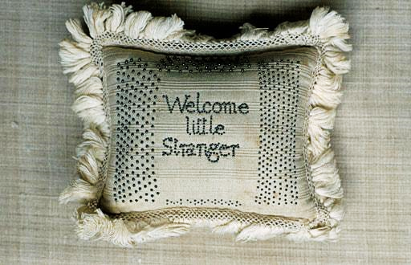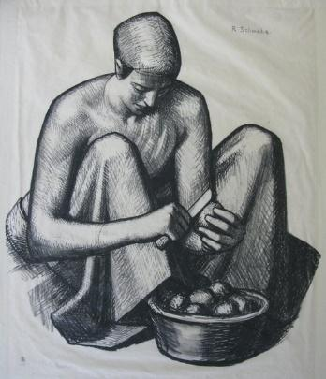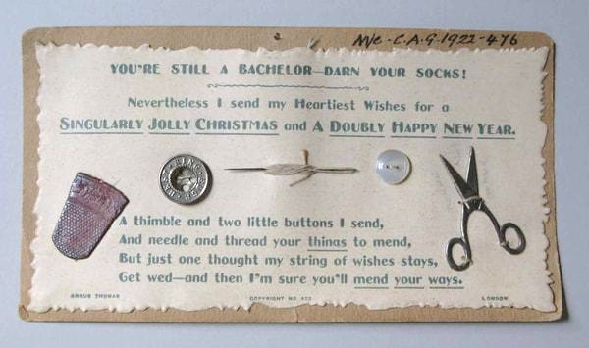
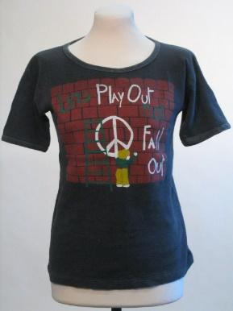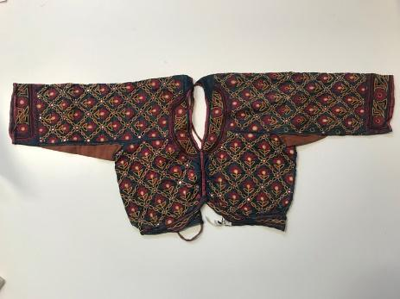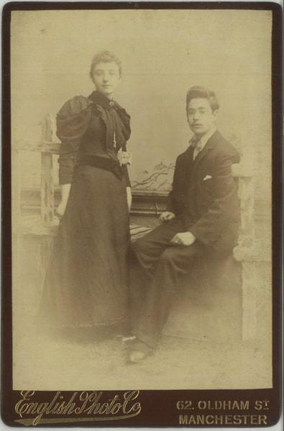
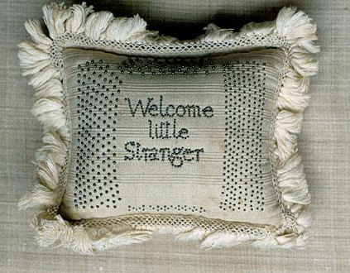
Principle 1
A welcoming, inclusive and free dwelling place. A place that is relaxed and homely, where you can ‘drop in’, and just be for a while. With good signage and exterior grounds that clearly convey that message.
We started with a pincushion, which says ‘welcome little stranger’, so we thought about establishing relationships and being open to someone who was a stranger.
Exterior welcome and relationship to the park
I think the outside is really important, if you don't feel you can walk in and be comfortable, you'll walk on past. The Hall has physical barriers and fencing and an off-putting appearance. There needs to be a sense that it’s part of the park and grounds, a fluidity between the two, not its own little silo by itself.
Better relations with other things in the park. What's the relationship with the other building right by the lake? Is there one? The Hall is on the edge of the park. So for those who come to use the park, they could easily go past it or in different ways. There has to be something that leads them off Wilmslow Road and through the park to that point. So that it is a place that they come across and a place that they think to go to. Otherwise you continue to have this separation between the hall and the park.

I'm interested in the way that you've been using the windows like a notice board, more than they've ever been used before, as far as I'm aware, that I think that's a really good way of breaking down barriers. That thing about can I or can I not go in that building, you know, it's locked down to everybody, but equally to everybody. But in that time, by using the windows, it gives out the impression that the intention is it for it to be for everybody. Ultimately.
The importance of the windows as premium advertising space that has real capacity to break down some of the barriers as to who is welcome, but is also a way of sharing thoughts, questions, issues and calls to action. You'd pay thousands for that if you were a company.
Community identity
Make it reflective of the different communities in the area, so they think it’s for them. Overcoming what I hear as a GP locally – ‘oh you couldn’t send me there, doc, that’s not for me’. So communication, signs, messages, use of media, and even ambient sound could make it more welcoming and comfortable. It’s also about being welcomed by the people.
A family draw is essential in the area that Platt Hall is based in, because there's lots of families in the area.
It’s important that people who are disabled or older people can get to the Hall as it’s a long way from entrances and exits so carparking would be useful, as well as accessible entrances, toilets, lifts etc. It needs big open entrances, available and accessible at a range of times to reflect the lifestyles of the community.

An active space
Establishing relationships of continuity with activities that draw people back for repeated visits. Somewhere people think of going more than once. A pop-up creative space, that changes, with opportunities for people to attend a range of occasions and broaden the aspect. Like Z-Arts, who successfully bring all sorts of pop-up installations.

Principle 2
An affordable café/kitchen and accessible toilets. Something community-run, simple, cheap and ‘homely’, and accessible for park users at different times of day. A kitchen as much as a café - where you can bring your own food, and cook together.
Responding to the drawing of a woman peeling potatoes, themes came up around the pleasures of cooking for others, different cultural foods and ingredients, sustainability, local produce and homegrown food.
Atmosphere
The café should be beautiful, homely, special, should feel like an occasion. A clearly defined space, so there aren’t other things going on, it’s clear what you do in that space. It needs to be clear opening times that everybody can remember. So you're not dipping in and out of all sorts of times because it's hard when you don't go regularly and struggle to remember things.
Sustainability
Really considering where our food comes from. Explore with different groups and communities how we access food. Building on the work of the Market Garden and their relationship with social prescribing. Look at gardening around and beyond the Hall including using the old bowling green and pavilion, currently unused and with lots of potential.
I thought about the connection with the Market Garden and the history of the collections. Perhaps there’s some scope for linking the heritage of the collections with food. Use that as a learning tool, so if people aren’t just interested in food or in textiles then tie it together.
In Old Trafford, there is someone who does lots of foraging and makes jams and preserves - is there an opportunity for creative making, for some kind of creative workshop around that, relating to locally sourced food but also foraged food.
For park users
A place where you can bring your own picnics or cups of tea. I think that's absolutely essential. It's really lacking in Platt Fields. A space where I can stay for some time, reflecting the hours of park users and local people, not set times like a gallery opening, but using the park and café as a rest space.
Saturday mornings, there are 500 people running around the park, and a lot of them get together and go off somewhere for coffee afterwards. There's no reason why it might not be possible to have the start and finish of the parkrun somewhere close to the Hall. And people could get coffees there and come into the Hall to create more of a sense of place. So it is a focal point, because I think that that's part of the issue, making it the focal point away from the lakeside.

It's useful to look at those that are popular already. There's a really good park cafe in Fletcher Moss Park and Alexandra Park too.

Community use
Some places have an idea of a kitchen and the idea of a cafe and they are not necessarily the same thing, and it’s worth contemplating this. A kitchen, which is created for the purposes of a cafe, might also be used to prepare food that may then be delivered elsewhere or may be available elsewhere.

How we serve the community around us, people who can’t get to the Hall, making food to go out to people. A lot of places have been contemplating how their kitchens can be used for preparing food for people in need locally. A really good model for that is Emmie’s Kitchen, they started an initiative at the Children’s Hospital, they’ve adapted to Covid, providing food for families of children in hospital.

From a neighbourhood's perspective, there is a huge need for an age friendly cafe. I think sometimes use of parks is massively enhanced by a cafe but it needs to be from an Age Friendly perspective. If they do have, you know, accessible toilets that people can use. So advertising that and making sure that when people do visit that you know it, they realise that it's open to a quite a wide range, and I think that'll be hugely beneficial.

Principle 3
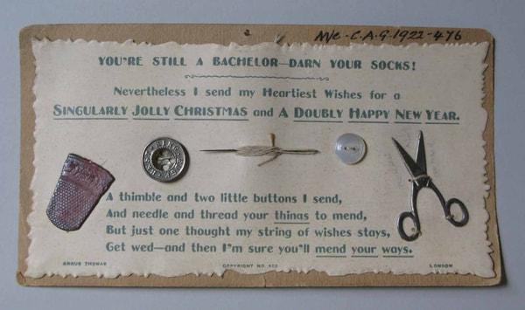
A place of creative making spaces and activities. Skills development and sharing, with an emphasis on life skills and sustainability - repair, make-do-and-mend - but also preservation of domestic crafts and hand-making.
Discussion around everyday life and domestic making, inspired by the example of a greetings card with a ‘bachelor’s darning kit’.
Analogue/digital
If you’re trying to get people in and engage them, then digital media isn’t the best thing to do for local people, something analogue, like an invitation card through the letterbox of surrounding houses. Doing things to come together, having more analogue tactile interaction, picking up on what we’ve been doing in lockdown. Maybe even replicate those little gifts for people for when they come. Definitely, definitely has to be more analogue.
Care and repair
Popularity of programmes like the Repair Shop and this idea of repairing things is much more in the zeitgeist at the moment. The bike hub is somewhere you can take things to get fixed but also learn how to fix it yourself.
There was a clothing swap in the Arndale. It was like a pop-up shop. And people took their clothes with them and you could have some some kind of event where people can bring clothes that need repair. A clothes swap, but also a make and mend session. I've just thrown away some t-shirts that I've had for nearly 20 years, it was quite emotional, but it would have been nice if there was something I could have taken them to to repurpose into something else.
I must mention the Platt Fields Bike Hub, that's been going for several years now. And the principle behind it is that you learn you don't just go and have your bike repaired by an expert. You work alongside the experienced cycle mechanics there. It's all volunteers course and you learn to repair your bike.
Skillshare
How about asking the community what skills they have? Talk to people like Lillian at the Place who seems to know everybody. Something like the postcard through people's doors to ask them to put what skills they have on it. And a post box outside Platt Hall that people could post the postcard back into, and you could bring those people together and have a discussion about what they could offer. Lots of people through COVID have wanted to volunteer, I know through my job working with mutual aid groups, that people still want to volunteer. There's lots of people who put their name down to volunteer and then didn't get to do anything because the amount of volunteers outweighed the need. I wonder if trying to identify what skills, talents, passions we've got locally, would work.
There is definitely something around skill. Whether it is inviting or encouraging people who may feel they don't have a skill that you can just come and have a go. And the fact that there are actually quite a lot of skills embedded in this area, and perhaps having some sort of database of skilled people that could be shared.

Principle 4
A place for collective engagement with social issues of relevance to the area. A neighbourhood hub for debate and collective action.
Platt Hall as a hub for broadening and maximising perspectives and approaches in our neighbourhood. Ideally placed on the borders of three wards, for the satellite interests to come together, a place where people can join up thinking, turn it into action from a grass roots perspective.
Joining the dots of local action
It would be great if there was a permanent place that was always open. The permanence of it gives weight to the ideas. So they aren't things that blow in or out. Somewhere people can actually go that could be place for meetings and information, workshops, and spaces on the timetable for things that crop up. Because it seems like at the moment, there's so many things that are layering over each other and they're all relevant to each other, but you need time and space to concentrate on them. A hub would capture as many different perspectives as possible because I think a lot of perspectives just aren't captured.
A funded post so there is a designated person who can identify local interests and concerns, map their connections and overlaps, and put people in touch with each other. There's loads of different community groups, all doing their own particular things. There's probably a lot of overlap between them but nothing really connecting those dots together. So if there was a place like this, where there was also a person identifying the crossovers between all these different groups and avoiding wasted or duplicated work.
The problem that we found at the Market Garden is, if you leave it up to volunteers, that everyone's got their own things going on. And eventually people move on. And if you've got one person that is dedicated to it, and they move away, it's hard to find another person that dedicated. You need someone that's actually paid to do that job.
So there’s a mapping, of different groups or networks that are pursuing particular areas of interest to the local area, whether it's litter picking or alley greening, or early years provision, all sorts of things that map across the neighbourhood, and would give them a sense of kind of joining up the dots.
Who to target and how?
Really important to engage young people. Do teenagers engage? Not sure mine would but some might, really important we do this in a targeted way, getting to know young people’s groups locally and finding out more about what matters to them.
Using festivals as a platform for talking about issues. Exploiting how people now understand what a pandemic is and that the corona effect has been global. Applied to other issues - how racism is itself a pandemic. A speaker’s corner or open mic events that can connect into various festivals, such as Black History Month or Diwali or Eid when people could come in and schools could come and use music and drama to knit the communities into Platt Hall.
An everyday person getting to talk about their experiences – not a keynote speaker or academic every time but ordinary people talking about their experiences – and not all negative, some positive – but if an everyday person talks about their struggle, how they feel alienated or isolated it would be a good opportunity for people to come closer. An open mic does that very well and can lead into local history recording.

Principle 5
Collections as a resource for sparking conversation, curiosity and creativity. A range of objects that reflect the diversity of the local area, combining the familiar and the unexpected. Opportunities to actively explore, respond, discover, not static displays that never change.
Discussion revolved around the collection as an active local resource, a support for local history and culture. Responding to an Indian garment from the collections, local knowledge and expertise especially in relation to non-Western collections was key.
Active collections
I think those final comments about static collections that never change. Much of the collection of Platt Hall did rather seem like that… certainly on the first floor, those big glass cages, it never seemed to change. … That's my perception. I’ve been going in and out over the years, and I’m conscious that the displays never seemed to change. If you don’t rise to that challenge then you end up with a gallery where people say ‘Oh yes I went there once’ and don’t need to go again
Displays that have inspired me… for example, there might be an artwork that has been there the whole time, and then they might put something else next to it. And somebody else might have written a label other than a curator, and I read that and I think ‘Oh, actually that thing that I thought I knew is very different now’ because I've seen someone else's interpretation or it's on a different colour wall or there's another artwork next to it. So looking at something you think you know really well and having it reimagined … to have these little moments to look at something afresh. You know, someone else's personal or cultural history, whatever it is, when they bring it to it, you're just like, ‘Oh, yeah, that helped me change my view too’.
I think… it's kind of the willingness to make more things available, and maybe being a little bit less precious about them, still caring for things and looking after things, but a willingness to explore and you know, have people come in. Have a rummage through what's there and see what's of interest.
An overarching theme or common thread
I would love there to be a common thread or some sort of sense of framework to it all, which is a sense of the history of the site, and particularly the Hall over many centuries. Because we're talking about our country, and also this city, and such a myriad of different forms and processes of engaging with the wider world, with other peoples, with other cultures, that's a constant factor, although it takes so many different forms. So there may have been connections with sugar, there's certainly connections with India, with Africa. But there'll be connections as well with the hinterland of Manchester, and I would just love that to be recognised as the thread that holds it all together, which joins us because we're all living through news. And what we're living through is a version of something that's always been here. It’s making people feel at home, in the sense that our history has always been about encounters. And sharing cultures, learning from, I'm sorry, stealing, obviously, a lot of it is not nice and is, is what we do have to face up to.
I just want to ask, doesn't Platt Hall have quite an international collection? I saw some of the objects there just before lock down. I’m interested to know in terms of the clothing and the costumes, I know the majority are from this part of the world, but which other parts of the world are they from?

Principle 6
A place to celebrate local history, local artists, local culture, working with the building, not against it. Valuing the history of the area as a way of instilling pride and making it better in the future.
A place for local history
You know, somewhere like Manchester Art Gallery or the Whitworth doesn't have that element of history at the forefront. I think that's really important in a place that feels much more local, and I think there's a desire to sort of feel at home in places and one of those ways that you can do that is to look around and think how things are changed. It's really changing, places like Rusholme, in so many ways, the communities and the way people pass in and through, documenting and recording that is really important and different, I think, to how a city centre gallery might feel. Do you know what I mean? I think it's really important to celebrate things that are different. And find things that have common ground, universal themes of family or food or things like that, that encourage conversation. But you can look at what happened 50 years ago, 100 years ago and talk about those changes that have happened in Rusholme. So I think it's a great place to feel a sense of belonging because I think sometimes you might feel well, that's nothing to do with me.
Because it’s not it's not my culture. I'm only living in here and now …like when you when you open up history and make it sort of connected, I guess with people's lives. They can really start to sort of see the importance of them.
I like the idea of storytelling around an object and I'm just going back to the pictures and the images, it would be nice to have those photos like the changing faces of the area and different people that have lived there. And because obviously Rusholme and the surrounding area is very different now. So just using it to look at, you know, the different and just like across the years, different people who have lived in the area.
Could I suggest something? You could invite people to choose some to be displayed and then have a story competition around them.
Valuing the costume history
A lot of people are concerned about keeping the focus on textiles and not turning your back on the history of costume and textiles and the collections from all over the world that have been here a long time, and not denying access to that. My own fear is that it would become a generic community centre, so please stay with textiles and clothes and international collections. A few of us brought that in.
I really hope that something around the clothing side of it is going to be preserved and maybe become a sort of focus of what happens there. Because it always seemed to me that so much could have been done around that. And what comes out of clothing draws in all sorts of people who wouldn't be normal museum types, you know, people who are younger people who are fashion conscious and interested, women who are interested in crafts, making clothing or doing something around repairing, never mind things like weaving, plaiting, it just seems to be the huge history and lots of our communities that could be drawn upon and would in turn bring people in, which then builds a sense of this as a welcoming place.

Nothing in those principles leads me to see a connection between the use of the Costume Collection as it has been up to this point as a collection of material, textiles, clothing, etc. Nothing about how it’s going to be taken into the future.

I wouldn't like it to lose its association centrally with costume, you know, fabric, because if it does, it will be just be another house and another multi layered experience. So I'm glad to hear that costume will still play a central role. And I would like to see that highlighted so that everything comes off that, it’s the common denominator. Otherwise, it'll get watered down.

Concluding thoughts
It would be interesting and good to keep having these conversations – to know what other people are thinking, so we might change our way of thinking or we might include or discuss something else, so it would be nice to know what others think and what is their view.
It doesn’t have to be all or nothing – some possibility of opening up the ground floor in the shorter term, surely, so we can do some more things.

Proposed next steps? For each principle and overall? Taken from project plan discussions?

