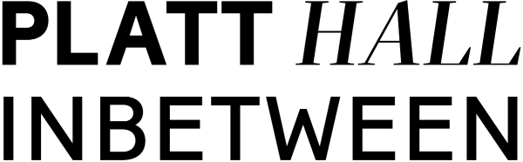
Collection Chats - Scriber freelance role

We are seeking a creative person to visually document Platt Hall Inbetween Collection Chats through handwritten text and drawings.

Platt Hall In-between is a project to explore the potential of Platt Hall. It's about re-connecting the Hall with its local communities, the people who live, work and play on its doorstep. About working together to make best use of this unique historic landmark and ensure its future for years to come.
We're working with a range of partners, from park users and residents' groups, to charities and a local GP practice. We're hosting conversations, explorations and investigations - researching the history of the Hall and local area, exploring Manchester's art collections to decide what should be here in the future, and finding out more about what people really want and need to make life better in this part of the city.

Collection Chats
Collection Chats take place on the third Thursday of each month from 11-12.15. The sessions provide a safe space for a small group of people and staff to select two objects from the Platt Hall Collection to share responses, reflections and experiences connected to them. Starting online as a response to isolation during lockdowns, we are now running the Chats live at Platt Hall.

The objects in the Platt Hall Collection provoke curiosity and are eclectic in their nature. As part of Manchester Art Gallery, Platt Hall is connected to over 50,000 objects and artworks in the city's collection. The Mary Greg Collection, long associated with Platt Hall, is an intriguing collection of over a thousand beautiful, yet humble everyday objects - from keys to miniature books, dolls’ houses and games, pin-cushions and spoons. The collection celebrates the handmade and the familiar. Objects from this collection have been the inspiration for Collections Chats.

Need for a Scriber
There is much unknown about many of the objects in the Collection and the sessions are an opportunity for staff to be challenged and learn new perspectives. We feel it is vital to capture these important conversations to achieve what we are learning through the Platt Hall Inbetween project. We have achieved this in-house whilst working online but feel it is the right time to invite a specific person to take on this role. Examples of previous recordings can be seen here https://www.platthall.org/collections-chat.html

Role description
- To handwrite and draw a recording of what is discussed during each Collection Chat.
- To do this live within each session with some time for tidying up afterwards.
- To digitally photograph each set of drawings/ notes
Required availability
- Every third Thursday of each month from 11-12.15. Required to be at the hall from 10.30-12.30.
- Available for other scribing/ documenting opportunities as and when required.

Fee
- £75 per Collection Chat conversation

Recruitment
We particularly welcome application from Black, Asian, Minority Ethnic artists who are currently underrepresented in our work.
We also welcome applications from artists who live and work in the neighbourhoods surrounding Platt Hall to help support the local creative infrastructure.
Where the artist is disabled, every effort will be made to supply all necessary aids, adaptations or equipment to allow the artist to carry out all the duties of the role.

To apply
Please send us a short, recorded film (3 mins, made on a phone) introducing yourself and telling us why you are interested in this role. Please also show some examples of relevant work.

This is our preferred option but if you would rather, send a description of the following on one side of A4 (typed)
- Why you are interested in this role.
- Examples of your style/ work

To Ruth Edson ruth.edson@manchester.gov.uk by Wednesday 9 March.

We will let you know by Mon 14 March if you are invited to come in for an informal interview on Thursday 10 March.

For more information about Platt Hall Inbetween, see https://www.platthall.org/

